Irfan Ahmed
ICP 9
Due Date: 10/26/2020
Data Explanation:
For this report Mean Squared Error, Y intercept and slope were calculated based on the insurance dataset used. I was trying to look at the cost of insurance charges and compare it with sex, age, bmi, region, smoker, and children. There is some indication that smokers do tend to pay higher cost but that could also be attributed to the person age as well and where they live. The MSE for this observation was 0.501, Y intercept 0.00566 and the slopes for each of the variable were the following: [ 0.29254799 -0.0116126 ,0.15938599, 0.03498638, 0.80153266, -0.0290586]. The r2_score was 0.754, which can be interpreted as less difference between the observed data and the fitted values. The MSE was 0.501, which could be the model needs improvement to get better understanding of if any further relationships can be assumed with the features and charges.

  - What you learned in the ICP
For this ICP the goal was to create a linear regression model. Linear regression can be used to find the relationship between continuous variables. Where one is the predictor/independent variable and the other is the dependent variable.
  - ICP description what was the task you were performing
- Imported the needed packages/libraries.
- Reading the csv file for insurance cost.
- Looked at the data to see what could be removed or changed.
- Checked for null values.
- Converted string into numerical representation using LabelEncoder. The sex, region and smoker strings were changed to their appropriate presentation.
- Used PCA on the dataset.
- Created feature list and X and y variable for train and test purposes.
- Both X and y datasets were standardized.
- Training and testing method were applied.
- Used LinearRegression() for analysis. The model was fitted for the X_train and y_train. Also, prediction value was calculated.
- Finally, the intercept, coefficient and MSE were calculated.
  - Challenges that you faced
My data size did not match at first but after playing around with different variable I was able to fix it to where I could run my model. Since I was comparing multiple columns, I had difficulty trying to visual that in my code.

  - Screen shots that shows the successful execution of each required step of your code
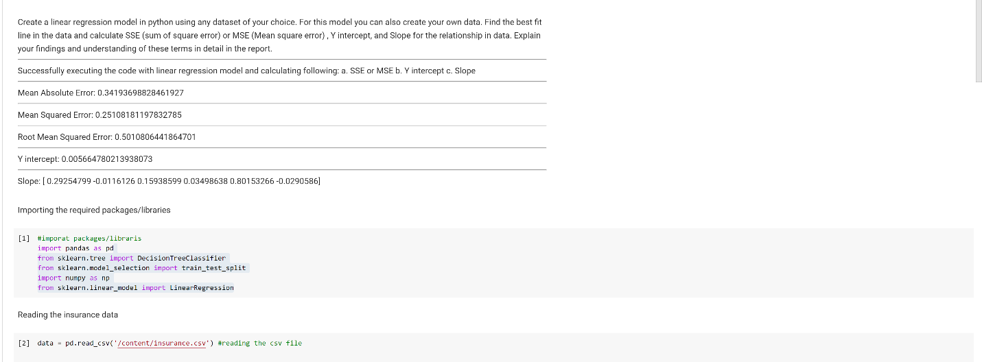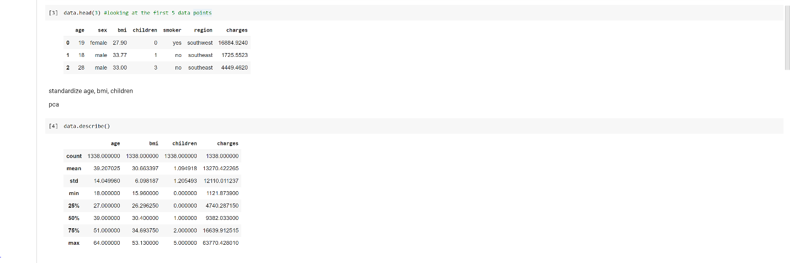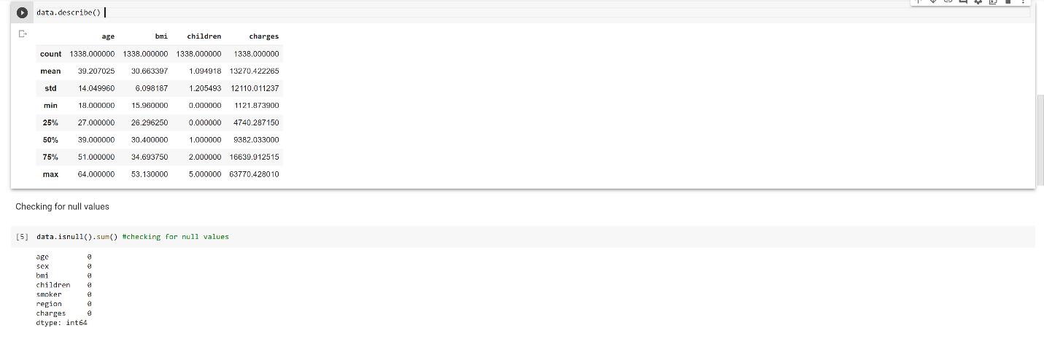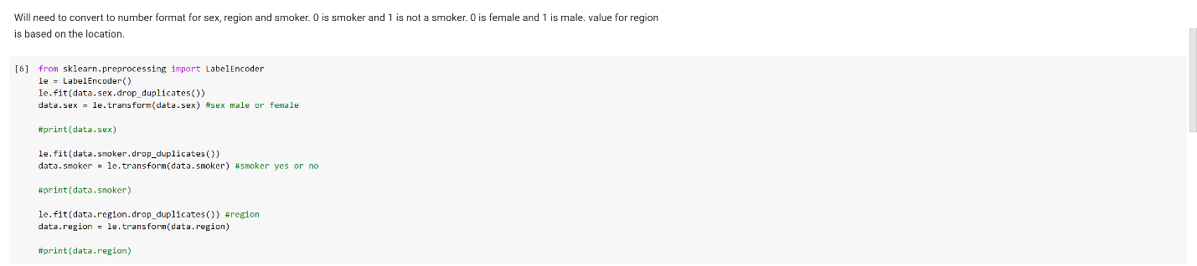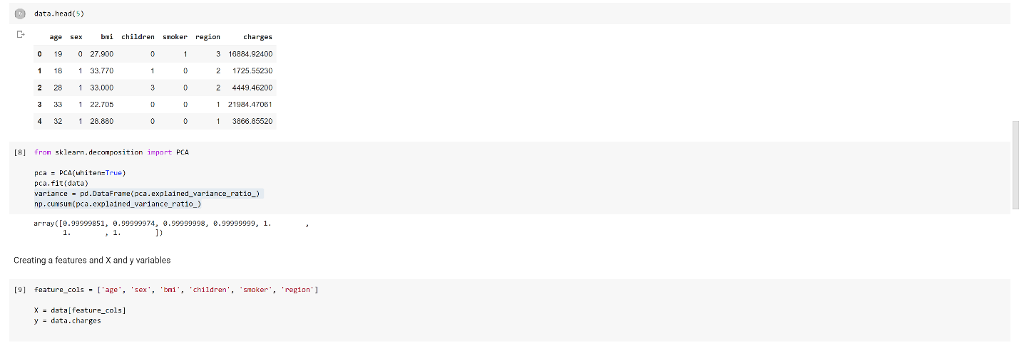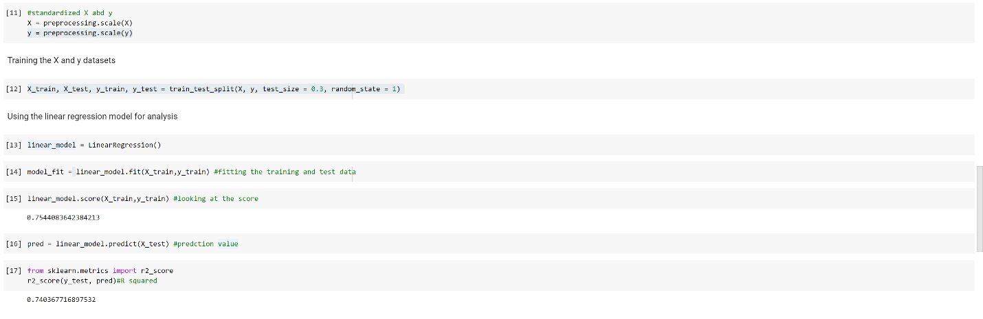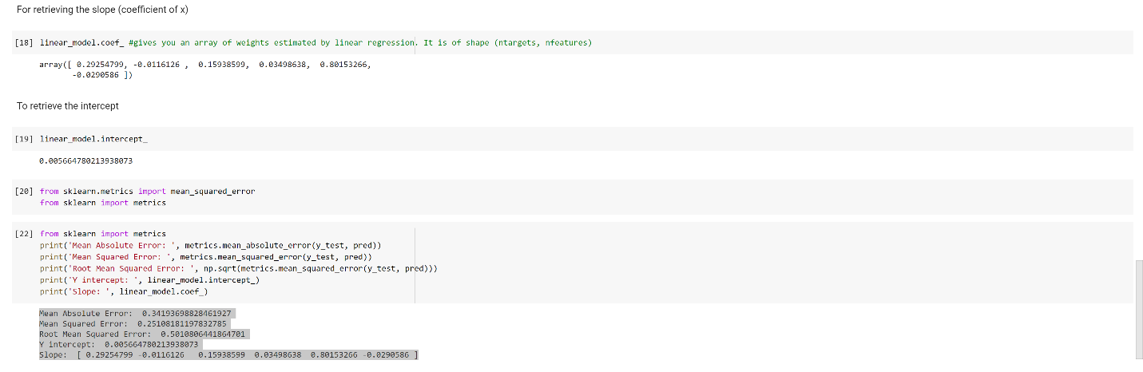
  - Output file link if applicable
https://github.com/UMKC-APL-BigDataAnalytics/icp9-irfancheemaa
  - Video link (YouTube or any other publicly available video platform)
https://umkc.hosted.panopto.com/Panopto/Pages/Viewer.aspx?id=9b7fe325-a1f8-4dcf-bf4a-ac6001505c68

  - Any inside about the data or the ICP in general
I really enjoyed this ICP because it allowed me to create my own model. Learning how to properly setup each step to make sure the next line of code be appropriate to write and use.

